ECE 411

Homework 2

Cameron Tribe

Sean Koppenhafer

Jaime Rodriguez

Travis Berger

**Project Ideas Summaries:**

nocLock:  
  
The nocLock is a safe that will lock/unlock when the user enters a specific knock sequence. The user will enter a knock sequence to lock the device, and then will later use that same knock sequence to unlock the device. The nocLock uses a microcontroller to interact with a piezo buzzer to sense the knock sequence and will also control a solenoid to lock/unlock the box. When the user enters a knock sequence to lock the device, the knock will be saved to eeprom to prevent users from simply disconnecting the power to break into the box.  
  
Light Sensing Automatic Plant Watering Device:  
  
Based off the slow drip plant watering globes, this device uses a photo-sensor to detect when the sunrises. When the sun does rise, a signal will be sent to open a valve that slowly waters the plants. This project meets the project requirements by using a microcontroller to communicate to the photo-sensor and the release valve. This project provides some challenges - mostly in the release valve. Correctly modeling the rate the device waters plants and in packaging the electronic components would be difficult. Extra features for this project are making it solar powered, allowing users to select what time of day for the plants to be watered, and making the device capable of dispensing different volumes of water.

Pattern Recognition Kids Game:

Pattern Recognition Kids Game is a project that would be a durable toy developed for small children. This toy would incorporate switches, buttons, and photo-sensors, that when activated, would deploy compressed air, lights, noises, and vibration. This project aims to include the senses of touch, hearing, and sight. An example of an interaction would be putting your finger over a light-sensor and a small amount of compressed air is deployed. Another example would be pressing a button that elicits a specific noise. This project meets the requirements by using a microcontroller to communicate between the sensors and the actuators. Challenges would include making the project safe for children, packaging the project in an appealing way, and interacting with foreign mechanical actuators and sensors.

Pill Dispenser:

The Pill Dispenser is a project that would dispense specific pills when a button is pressed. The user would pour their specific prescriptions into specific slots. They would then program the device by pressing three different buttons denoted by day of the week, location of slot, and number of pills that need to be dispensed. After the device is programmed, the user presses the button for Monday, and the correct number of pills for Monday would be dispensed. One of the applications for this device would be for a nurse. The nurse would program the dispenser, and then the patient would only need to press a button to get their medicine for the day. Features include only being able to press the button and get pills once for a certain day or time of day. This would make it so patients who had forgotten that they had taken their medicine wouldn’t take their medicine twice. The main challenge of this product would be the mechanical pill dispensing system. It would be a challenge to only dispense one pill at a time.

**Decision Matrix:**

|  |  |  |  |  |  |
| --- | --- | --- | --- | --- | --- |
| **Project Ideas** | **Jaime’s Order** | **Cameron’s Order** | **Sean’s Order** | **Travis’s Order** | **Total** |
| Secret knock detector | 4 | 4 | 4 | 3 | 15 |
| Automatic plant watering | 3 | 2 | 3 | 4 | 12 |
| Pattern recognition kids game | 1 | 3 | 1 | 1 | 6 |
| Pill dispenser | 3 | 1 | 2 | 3 | 9 |

To eliminate three of these, we each listed our most desired choices from first to last. We assigned numerical values to each position, for example our first pick got 4 points, second got 3 and so on. After we each had our lists, we added up the total points and chose the one with the highest amount of points. We all agreed that the scope of secret knock detector was on par with the objective of this course, and would be feasible in the remaining time. It was also agreed that this particular project would be interesting for all of us, as it has components that cross over in to all of our fields of study.

**Project Proposal:**

The nocLock incorporates all the requirements needed for this project and creates an innovative new approach to security solutions and access control. Have you ever needed to open a door or lock and found yourself with your hands full? Avoid putting down the groceries with the nocLock by opening the lock with your secret knock. Now imagine having the availability to add this concept to any type of lock - a car door, a window, a safe, etc. In this project we will create just that; a compact module that can be adapted to be used on many locking application.

This knock approach will allow the user to set up a secret knock that can then be later used to unlock the lock. Using a microcontroller as the brains of the design, we will use a piezo buzzer as a sensor mounted to the same surface as the lock. The piezo buzzer will begin listening for knocks after being initiated by a button press. LEDs will be used to confirm successful or rejected knock sequences. If a correct knock is accepted, a solenoid will then be activated, thus opening the lock.

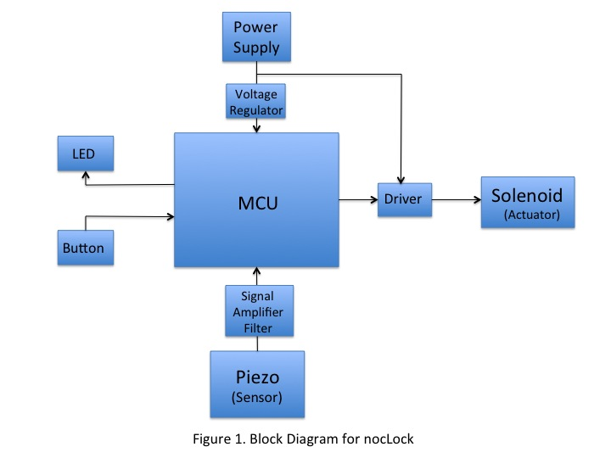

# This idea was inspired by an Adafruit project call the “[Secret Knock Activated Drawer Lock](https://learn.adafruit.com/secret-knock-activated-drawer-lock/overview)”. That project shares the same concept as our design, but we will take the idea further and create a more refined package that could also be applied to many different locking applications.